 | Website Info http://afe.easia.columbia.edu/mongols/ | Impressions of others from quotes | POV—Assess Accuracy
Political
(Leadership)

Economic
(What was their impact?)

Religious
(What was their impact?)

Social
(What was life like?)

Intellectual/Invention (How did they do it?)

Aesthetic
(Were they so bad?)

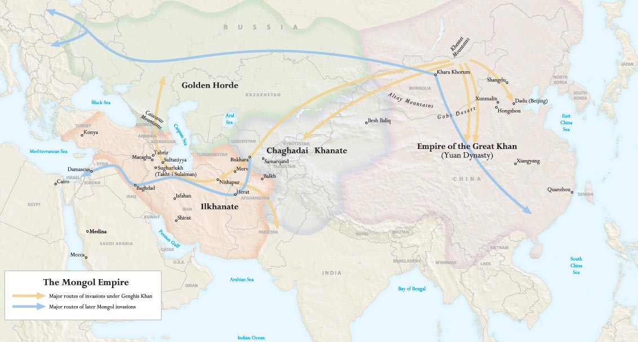
Describe the geography of the empire and its impact on the administration of the empire.

