Theme Icons Note Chart: _______________________________________________
Theme | Notes
Environment: Human Migration & Patterns of Settlement

Environment: Human Demography, Disease, & Environmental Interaction

Cultures: Religion, Philosophy, & Ideology

Cultures: Architecture, Art, Science, and Technology

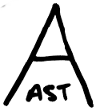

Political: Structures, Forms of Rule, & Technology

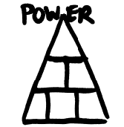

Economic: Production, Labor Systems, Trade, & Technology

Social: Gender Roles, Organization, Race, & Education

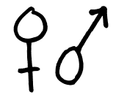

Cross-Cultural Interaction

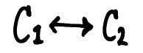

Continuity and Change

Cause and Effect

