Lesson One
Document 1A
Human Equality:
SELECTIONS FROM THE LEVIATHAN Thomas Hobbes (1588-1679) (Primary Source)
Nature has made men so equal, in the faculties of the body and mind; as that though there be found one man sometimes manifestly stronger in body, or of quicker mind than another, yet when all is reckoned together, the difference between man and man, is not so considerable. . .
For such is the nature of men, that howsoever they may acknowledge many others to be more witty, or more eloquent, or more learned; yet they will hardly believe there be many so wise as themselves. . . .
The State of Nature:
From this equality of ability, arises equality of hope in the attaining of our ends. And therefore if any two men desire the same thing, which nevertheless they cannot both enjoy, they become enemies. . . .
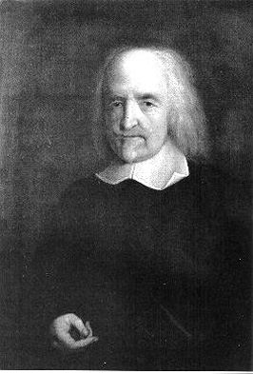
Thomas Hobbes
Hereby it is manifest, that during the time men live without a common power to keep them all in awe, they are in that condition which is called war; and such a war, as is of every man, against every man. For war consists not in battle only, or the act of fighting, but in a tract of time, wherein the will to contend by battle is sufficiently known.
In such condition there is no place for industry [meaning productive labor, not industry in modern sense of factories], because the fruit thereof is uncertain, and consequently no culture of the earth; no navigation, nor use of the commodities that may be imported by sea; no commodious building . . . no knowledge of the face of the earth; no account of time; no arts; no letters; no society; and, which is worst of all, continual fear and danger of violent death; and the life of man, solitary, poor, nasty,
brutish, and short.
15
Lesson One
Document 1B
The State of Nature
SELECTIONS FROM OF CIVIL GOVERNMENT John Locke (16321704) (Primary Source)
To understand political power aright, we must consider what state all men are naturally in, and that is, a state of perfect freedom to order their actions and dispose of their possessions and persons, as they think fit, within the bounds of the law of nature; without asking leave, or depending upon the will of any other man. . . .
The state of nature has a law of nature to govern it, which obliges every one: and reason, which is that law, teaches all mankind, that being all equal and independent, no one ought to harm another in his life, health, liberty, or possessions: for men [are] all the workmanship of one omnipotent and infinitely wise Maker; all the servants of one sovereign master, sent into the world by his order, and about his business. . . .
Reason
Men living together according to reason, without a common superior on earth, with authority to judge between them, is properly the state of nature.
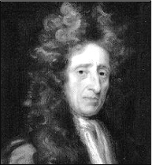
John Locke
God, who hath given the world to men in com- mon, hath also given them reason to make use of it to the best advantage of life, and convenience. The earth, and all that is therein, is given to men for the support and comfort of their being.
Nothing was made by God for man to spoil or destroy. And thus, considering the plenty of natural provision there was a long time in the world, and the few spenders . . . there could be then little room for quarrels or contentions about property so established.
16
Lesson One
Document 1C
SELECTIONS FROM THE SPIRIT OF THE LAWS (1749) Charles de Secondat, Baron de Montesquieu (1689-1755) (Primary Source)
Of the Laws in General
Laws, in their most general meaning, are the necessary relations arising from the nature of things. In this sense, all beings have their laws, the Deity his laws, the material world its laws, the intelligences superior to man their laws, the beasts their laws, man his laws. . . .
Since we observe that the world, though formed by the motion of matter, and void of understanding, subsists through so long a succession of ages, its motions must certainly be directed by invariable laws. . . .
Law in general is human reason, inasmuch as it governs all the inhabitants of the earth; the political and civil laws of each nation ought to be only the particular cases in which human reason is applied.
They should be adapted in this manner to the people for whom they are framed, because it is most unlikely that the laws of one nation will suit another.
They should be relative to the nature and principle of each government. . . . They should be relative to the climate of each country, to the quality of its soil, to its situation and extent, to the principal occupation of the inhabitants, whether farmers, huntsmen, or shepherds: they should have a relation to the degree of liberty which the constitution will bear, to the religion of the inhabitants, to their manners, and customs . . . in all which different respects they ought to be considered.
17
Lesson One
Document 1D
SELECTIONS FROM THE SPIRIT OF THE LAWS (1749) Charles de Secondat, Baron de Montesquieu (16891755)
(Primary Source)
Of Political Liberty and the Constitution of England
Political liberty is to be found only in moderate governments; and even in these it is not always found. It is there only when there is no abuse of power: but constant experience shows us that every man invested with power is apt to abuse it, and to carry his authority as far as it will go.
To prevent this abuse, it is necessary, from the very nature of things, that power should be a check to power.
The political liberty of the subject is a tranquility of mind arising from the opinion each person has of his safety. In order to have this liberty, it is requisite the government be so constituted as one man need not be afraid of another.
When the legislative and executive powers are united in the same person, or in the same body of magistrates, there can be no liberty. . . .
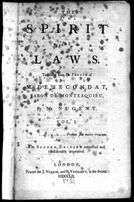
Image of the 1752 edition title page. Reprinted online: http://www.constitution.org/cm/sol_front.jpg
(February 1999)
Again, there is no liberty if the judiciary power be not separated from the legislative and executive.
In perusing the admirable treatise of Tacitus on the manners of the ancient German tribes, we find it is from that nation the English have borrowed the idea of their political government. This beau- tiful system was invented first in the woods. . . .
Neither do I pretend by this to undervalue other governments, nor to say that this extreme politi- cal liberty ought to give uneasiness to those who have only a moderate share of it. How should I have any such design; I who think that even the highest refinement of reason is not always desir- able, and that mankind generally find their ac- count better in mediums than in extremes?
Source: Montesquieu, Charles de Secondat, baron de The Complete Works of M. de Montesquieu (London: T. Evans and W. Davis, 1777).
18
Lesson One
Document 1E
SELECTIONS FROM THE SOCIAL CONTRACT (1762) Jean Jacques Rousseau (1712-1778) (Primary Source)
Man is born free, and everywhere he is in chains. Many a one believes himself the master of others, and yet he is a greater slave than they.
. . . [T]he social order is a sacred right which serves as a foundation for all others . . . now, as men cannot create any new forces, but only combine and direct those that exist, they have no other means of self-preservation than to form...a sum of forces which may overcome the resistance, to put them in action . . . and to make them work in concert.
This sum of forces can be produced only by the combination of man; but the strength and freedom of each man being the chief instruments of his preservation, how can he pledge them without injuring himself, and without neglecting the cares which he owes to himself? This difficulty, applied to my subject, may be expressed in these terms:
To find a form of association which may defend and protect with the whole force of the community the person and property of all its members and by means of which each, coalescing with all, may nevertheless obey only himself, and remain
as free as before. Such is the fundamental problem of which the social contract furnishes the solution.
In short, each giving himself to all, gives himself to nobody. . .
We see from this formula that the act of association contains a reciprocal engagement between the public and individuals, and that every individual . . . is engaged in a double relation. . . .
. . . the social pact . . . includes this engagement . . . that whoever refuses to obey the general will shall be constrained to do so by the whole body; which means nothing else than that he shall be forced to be free. . . .
Source: Rousseau, The Social Contract, Henry J. Tozer, trans. (London, 1895).
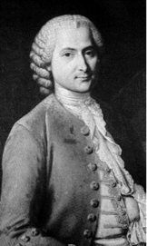
Jean Jacques Rousseau

